**Technical Proposal**

**­­­**

**part of the Northern Consortium Jenin Proposal**

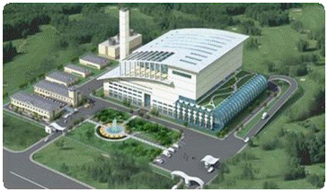

# Table of Contents

Table of Contents 2

1 Introduction 4

2 Methodology statement 6

2.1 Specific Requirements according to RFB 6

2.2 Appreciation of the project 7

2.3 Project Sequencing 8

2.4 Facilities to be provided, including plant capacity and efficiency 9

2.5 Design standards 12

2.6 Basis for Calculations 13

3 Process Flow Chart and Material Balance Statement 14

3.1 Specific Requirements according to RFB 14

3.2 Process flow chart 14

3.3 Material balance statement 15

3.4 Supporting calculations and assumptions 17

3.5 Life cycle cost analysis 17

4 Resource Utilization Statement 18

4.1 Specific Requirements according to RFB 18

4.2 Manpower deployment including CV’s of senior staff 18

4.3 Equipment procurement and utilization 23

4.4 Procurement and Contracting activities 24

4.5 Support Infrastructure 25

5 Area Allocation Statement 26

5.1 Specific Requirements according to RFB 26

5.2 Site location and overall layout 26

5.3 Facilities Placement 28

5.4 Site Conditions 30

6 Operations and Maintenance Scheme 32

6.1 Specific Requirements according to RFB 32

6.2 Overall O&M scheme 32

6.3 Regular Maintenance Plans (planned maintenance) 35

6.4 Emergency maintenance procedure (unplanned maintenance) 36

6.5 Risk Management 37

6.6 Hand-back procedure 37

7 Time Schedule 38

7.1 Specific Requirements according to RFB 38

7.2 Overall schedule 38

7.3 Construction schedule 39

7.4 Operations and Maintenance Schedule 40

7.5 Reporting and feedback timelines 43

8 EHS Policy and Practice 44

8.1 Specific Requirements according to RFB 44

8.2 EHS Management Policy 44

8.3 Safety related issues 46

9 Additional options 47

# 

# Introduction

Reducing the need for landfills by establishing High-Efficiency Waste-to-Energy (HE WTE) plants plays an important role in tackling climate change globally and creating healthy societies locally. The Northern Consortium intends to closely work together with MoLG, JSC and local communities develop and operate a state of the art and most efficient WTE facility for at least 25 years. This will hugely reduce dependency on the Zahrat Al Finjan Landfill capacity and delivering 24/7 baseload native electricity to the Palestine Territories, reducing the high dependency on power imports.   
Our Northern Consortium consists of technology providers who are experts in their fields and have a proven track-record of designing, constructing and operating WTE and other energy infrastructure plants on various continents. The technical knowledge is combined with the best and most relevant local knowledge available.

As part of the *Request for Bids ICB for Waste to Energy Incineration Plant at Zahrat Al Finjan Landfill- Jenin Governorate* (Project No. MOLG2020-1/20), the “RFB”, MoLG requests our Technical Proposal for the design, construction, financing, operation and maintenance of a plant capable to handle a minimum of 1,200 tons of waste (MSW) per day, as per RFB Section 3.3.1.

We propose to construct a 1200 tons per day High Efficiency Waste-to-Energy plant based on the robust and proven *moving grate incineration* technology. A higher capacity may be opted for during the feasibility study phase to accommodate future increase of waste production if necessary and will further increase the energy autonomy of Palestine. The actual size will be determined during the feasibility phase. This technology is already successfully operational since 2007 at the Amsterdam High Efficiency WTE Plant in the Netherlands. Our solution will produce 30-60% more electricity, it will have the lowest CO2 emissions per MWh, and the highest waste recovery rate when compared to conventional WTE technologies.

Our High Efficiency WTE concept covers the whole system: from waste acceptance to treatment (including incineration, water-steam cycle and flue gas treatment) and electricity production:

|  |  |
| --- | --- |
| Gross output | 43-45 MW (@9000 kJ/kg) |
| Efficiency | **31-33% gross (~28-30% nett)** |
| Availability | **> 90%** |
| Diversion from landfill | **> 90% (depending local regulations on bottom ash)** |
| Emission standard | **EUdir2010/75 updated BREF 2019** |
| Type | **Moving grate incinerator** |

The maximization of value from the waste through the higher electricity production and lower emissions, will allow the High-Efficiency WTE plant to be potentially eligible for carbon credit subsidies, well above alternatives with lower power output per ton of waste.

The High Efficiency WTE plant proposed by the Northern Consortium is graded as unique according to DNV-GL (ref. Appendix B). It is the beyond “best available technology” (BAT) from an OECD country. It has proven to function robustly and sustainably for more than 10 years at AEB Amsterdam (The Netherlands). The High Efficiency Technology is elaborated on in Appendix A The Reference Plant, chapter 1.6: *The Clean and Safe Sink-Solution*.

Northern Consortium partners are passionate about Urban Clean-up and extremely motivated to support the JSC and MoLG with the powerful combination of best-in-class technology and an attractive business model. Together, we want to turn the growing volume of residual waste into clean energy and local jobs, while kickstarting a circular economy in Palestine sustainably (see also Chapter 9. Additional Options)

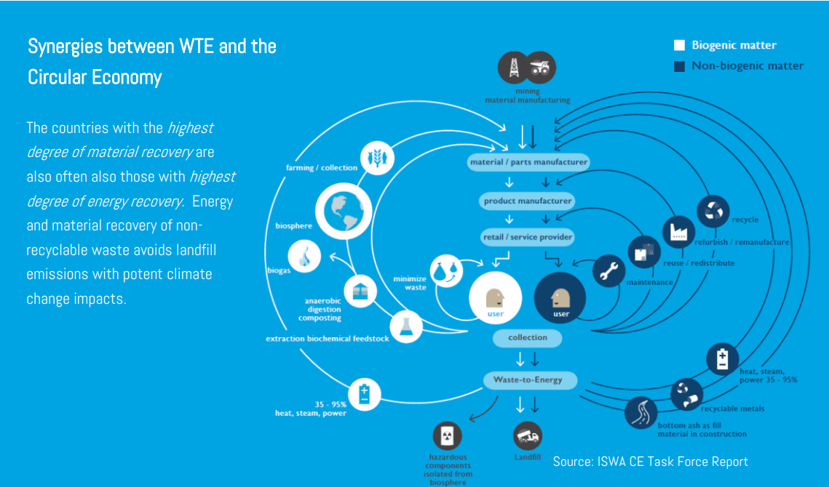

Figure The Circular Economy

Overall, the Project proposed will create:

1. Clean, reliable energy, financially attractive for the shareholders with 30-60% higher electricity production than other conventional WTE alternatives.
2. Low GHG emissions with our most environmentally friendly solution, following all requirements from the perspective of sustainability, health and safety.
3. Local employment associated to a new standard for waste management in Palestine as the first of its kind WTE plant, a lighthouse project for Jenin.

# Methodology statement

## Specific Requirements according to RFB

*“The Bidder shall provide a methodology statement, which broadly sets out the approach to the Project. The methodology statement shall include the Bidder's appreciation of the Project, the sequencing of activities to be performed, the facilities to be provided, design standards. The methodology shall detail the financial proposal including the financial plan with proposed financing resources, the financial model, and the cashflow.*

*The methodology statement should clearly demonstrate the compliance of the approach to be adopted by the Bidder for the implementation of the Project to the minimum requirements set out in the Concession Agreement.”*

Scoring Parameters

|  |  |  |  |
| --- | --- | --- | --- |
| Criteria | Parameters | Paragraph | Weight |
| Methodology Statement | * Appreciation of the Project * Project sequencing * Facilities to be provided, including plant capacity and efficiency incl. Preliminary design * Design standards * Basis for calculations incl.   Proposed Financing Sources   * Financial plan * Financial model * Cashflow | 2.2  2.3  2.4  2.5  2.6 | 20 / 100 |

## Appreciation of the project

The Joint Service Council (JSC) for Solid Waste Management in Jenin operates the sanitary landfill at Zahrat Al Finjan Landfill since 2005 and receives municipal waste from 5 Governorates in the Northern part of the West-Bank in Palestine. The Ministry of Local Government (MoLG) decided that the JSC should develop a more advanced waste treatment system where municipal solid waste (MSW) received at the landfill is converted it to energy through a Waste-to-Energy (WTE) incineration facility. Currently, the JSC receives over 400,000 tons of municipal waste (MSW) per year, a quantity that has been constantly growing over the past 11 years.

WTE plants burn household and similar waste that could not be prevented or recycled. From this waste incineration process the plants generate energy in the form of electricity, steam or hot water. The electricity is fed into the grid and distributed to the end-users; the hot water, depending on local infrastructure can be sent to a nearby district heating (or cooling) network to heat (or cool) homes, hospitals, offices etc., and the steam can be used by the nearby industry in their production processes. Waste-to-Energy is a hygienic method of treating waste, reducing its volume by about 90%. Modern Waste-to-Energy plants built in Europe are clean and safe, meeting the strictest emission limit values placed on any industry in the EU.

During the RFB process, MoLG unambiguously expressed their interest in minimizing the amount of waste that is currently accumulating at the existing sanitary landfill with several challenges for society and the environment. The creation of a modern and efficient solid waste incineration plant will ensure a long-term sustainable approach to waste management in the region. For the local communities surrounding the facilities important topics are reduction of odour nuisance and water pollution problems and at the same time creation of jobs in this new line of business. It is in the interest of MoLG to look for solutions that *maximize the energy output* per ton of waste, at the best price for the electricity delivered and with minimal impact on the environment, while serving the local communities in the best way through the project’s lifetime.

This first plant needs to be developed adjacent to the existing landfill area. It shall comply with the Technical Requirements, the Design and Certification Procedure and the Government’s Review Procedure as per the Concession Agreement provided. JSC will be responsible for municipal waste delivery to the weighbridge of the new plant. The Concessionaire shall operate the Plant for a period of 25 years and sell the electricity to PETL. Our proposed solution will generate well above the required 25MW of electrical energy, while we can divert more than 90% of the waste from needing depositing at the landfill instead turning the waste into energy and new materials. The expected and proven availability will easily exceed the required 80%, based on the performance of >92% in the reference plant over the past ten years.

This method statement will address the project sequence, design principles and standards as well as a preliminary financial assessment taking the Technical Requirements and all of the above into consideration.

## Project Sequencing

In order to develop a HE waste-to-energy facility from idea to operation, the following development stages and milestones are defined, based on Front-End Loading[1] (FEL):



Figure 2 Gate Process

1. Conceptual phase (FEL-1). In this phase, an opportunity is investigated. Also, partner- and relationships are built. Governmental bidding procedures are part of this phase. The conceptual design of the intended plant and its basic configurations will be determined.
2. Feasibility Phase (FEL-2). This phase determines whether the project is technical, economical & environmental feasible for involved parties. In this phase the conceptual design will be assessed and approved.
3. Definition Phase (FEL-3). In this phase, the exact ‘definition’ of the project is established, an EPC will be selected, and financing is secured. The conceptual design will be translated in a basic engineering package (BE) and all design parameters will be fixed for the detailed engineering (DE) phase. This phase will result in Financial Close (FC) for the project.
4. EPC Phase. This phase is where the facility is designed in detail, procurement of parts from suppliers will be done, and the facility will be constructed. The plant will have its start-up and guarantee test runs, before hand over (HO) at commercial operation date (COD).
5. Operate and Maintain Phase. In this phase, the plant will convert waste to energy, following the PPA, Waste Concession and other agreements. This includes performance on electrical output (MW), availability, emission levels and compliance with regulations, etc.

To control the risks during these development stages, the Northern Consortium will manage its development process with the ‘gate process’[2] as depicted above. In order to pass to a next phase, prescribed deliverables have to be approved through a ‘gate review’ and go through external checks by the authorities amongst others.

## Facilities to be provided, including plant capacity and efficiency

The first step towards a holistic sustainable waste management system for Jenin and subject of this bid is a Waste to Energy plant to convert all residual waste streams into energy.

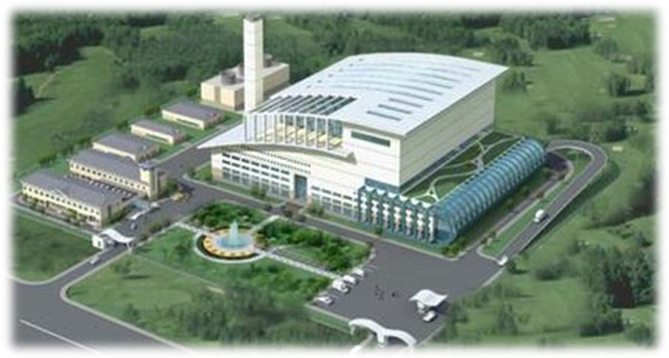

Figure 3 Impression of High Efficiency Technology/4th generation WTE

Our proposed High Efficiency WTE plant can handle a minimum of 1,200 tons per day (TPD) and allows for potential reduction of already accumulated waste and be prepared for further growth in waste volumes (the exact size may have to be adjusted during the feasibility phase when all assumptions sand information will be checked again).

The entire system shall include receiving area, storage/bunker, incineration/boiler, turbine, double-dry flue gas treatment, water-steam cycle, offices, visitor centre, and connection to the local power grid that complies with local requirements and fulfils international standards for waste to energy plants and their emissions.

During the feasibility and definition phase, critical topics such as:

* 1. usage of water, a scarce resource in Palestine;
  2. the connection to the local electricity grid, that is likely to need an upgrade for receiving the power of the new WTE plant; and
  3. the remaining partly inert fractions of the waste after incineration, which can be cleaned and reused for construction materials plus the hazardous fraction from Flue Gas cleaning which will be immobilized and safely stored, will be addressed.
  4. Temporary storage for waste to overcome delivering issues.

According to the Feasibility Study Report which was shared as part of the RFB and based on our own local knowledge, the current grid connection may not be suited to receive our expected power output. We will verify this at the start of our project and if needed modify the current substation in order to accommodate the export of ~40 MW to the grid. If this is not feasible, we will find together with PETL another location to feed in. Additional cost is accounted for upgrading the local substation. If it will be necessary to find another feed in location additional cost allocated but with a high uncertainty due to lack of information.

A side view of the proposed plant structure is presented below, and in Appendix C in larger format.

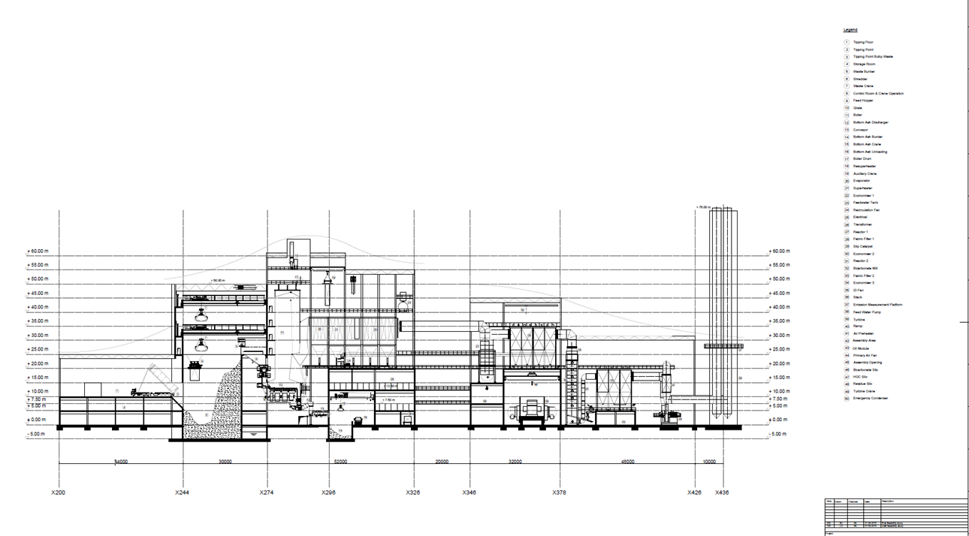

Figure 4 Layout of the proposed WTE plant with double dry FGT

**Key features of the facility**

The Project consists of the following key features:

1. Waste Reception & storage
   * Weighing bridge
   * Intermediate storage facility outside the plant
   * A bunker for a minimum of 5 days storage
2. Steam & Energy production
   * Chute
   * Dosing and grate
   * Boiler including SNCR (selective non-catalytic reduction)
   * Steam-water cycle
   * Turbine Reheater
   * Condenser
   * Air-cooled condenser
3. Flue Gas Treatment
   * FGT system
   * Reactor for Bi-carbonate and active cokes injection
   * Bag-filter
   * SCR for Denox (optional, to be determined in basic engineering)
   * Reactor for lime injection (extra cokes injection optional)
   * FGT heat exchanger for extra heat recovery and possible water production (optional)
4. Utilities
   * Chemical storage facilities
   * EM generator
   * Firefighting system
   * LAB facility
   * Other: compressed air, HVAC, DEMI water installation

**Waste storage for plant operation continuation**

In our HE WTE concept for this Project, a waste acceptance area and weighing bridges for incoming and outgoing waste are included. The plant will have a bunker facility for storage of the waste. In the bunker the waste will be mixed dried and fed into the chute of the incinerator. The bunker will have a capacity to store waste for 5-7 days to overcome disruption of waste delivery, weekends, festivities and holidays. As an additional contingency for longer durations of insufficient supply of MSW, we propose to designate an emergency storage site at the landfill for long-term storage of baled waste. This will be decided on in collaboration with the JSC.

**Plant capacity and efficiency**

|  |  |  |
| --- | --- | --- |
| Capacity | 1200 | Tons/Day |
| 2 lines | 665 | T/D @ 90% availability |
| LHV | 9000 | MJ/T |
| Rated output gross | 43-45 | MW @1200 T/D throughput |
| Targeted Efficiency gross | ~ 31-33 | % |

## Design standards

The proposed Project will be based on the reference plant[3] at AEB in Amsterdam, where the 4th generation WTE plant was realized in 2007 and has been operating successfully ever since.   
The 4th generation is also known as the High Efficiency WTE plant, which combines the HE technology and HE philosophy. The HE philosophy is about designing for **maximum recovery of materials and energy**, following a design aimed at the lowest Total Cost of Ownership (TCO). Regarding emissions to the environment the ALARA principle (*As Low As Reasonable Achievable*) is used, following the European standards and out-performing these where reasonably possible.

Above all, Safety has the highest priority throughout the design process and operational execution of the Project. Safety First!

Our design will be compliant with the following international QA/QC standards, following the Quality Assurance Management Plan QAMP guidelines: ANSI, ASME ISO-9712. To ensure the integrity of the installation the appropriate materials, testing and welding instructions will be provided. This way optimization in availability and lifetime can be reached from the perspective of total cost of ownership (TCO).

Next to these international guidelines and high-quality design principles, we will follow local regulations and practices, such as local economic and social development planning, local government planning and city construction principles, and follow the Palestinian policies for environmental protection besides adhering to the EU standards.

The following design principles are the basis for Jenin WTE project:

1. Choose energy savings, usage of advanced and reliable equipment with a higher level of mechanization and automation to improve the production efficiency to reduce labour intensity, improve the working environment, and assure safe production.
2. Protect the environment and prevent secondary pollution. This means that the emissions of pollutants can meet the ultra-clean emissions of the Netherlands standards, which are **more stringent than the EU2010 directive**. We use the Best Available Technology (BAT) to reach beyond the minimum standard of EU directive EU2010/75 *updated BREF 2019*, following ALARA principal.
3. Rational utilization of land, giving enough space for the key components in the production process, reduced land occupancy, buildings centralized as much as possible, keep more landscaping and gardening, which does not only beautify the environment but also can reduce the ambient noise.
4. Apply system design to save and re-use water, internal electricity use, strengthen energy reuse and avoid the waste of resources.
5. Make connections to the available local waste infrastructure, water connections, sewage connection, power connections and logistics early on to integrate the Project smoothly into the existing infrastructure and procedures. This will be done in close cooperation with the local government and other stakeholders. The project will only be responsible for all these items within the battery limits.
6. Plant construction will prioritize modern style design, being concise and lively, while at the same time having local characteristics displaying environmental harmony and it will have an identifiable signature.

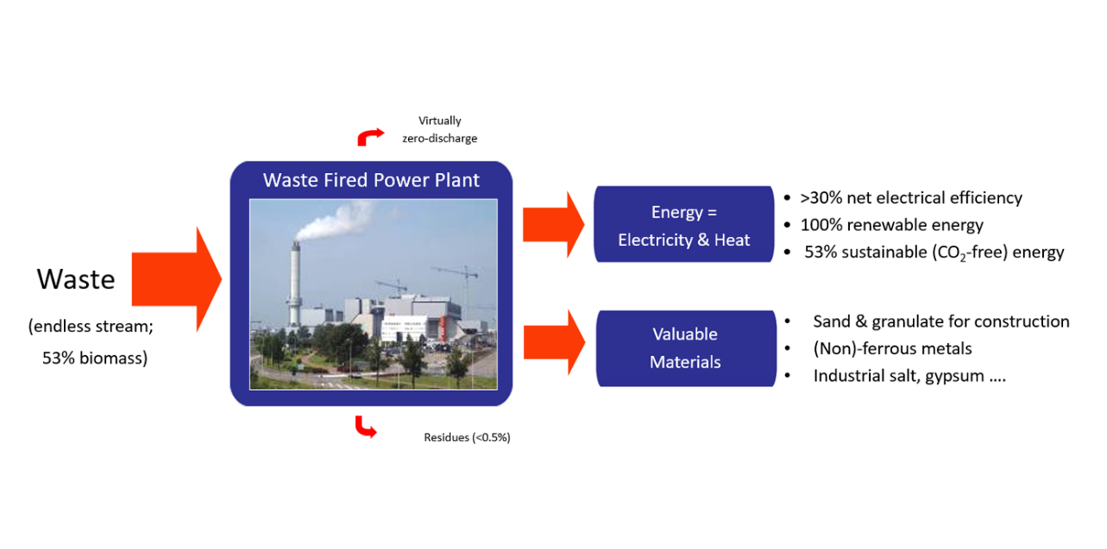



Figure 5 - 4th Generation: Waste to Power in a nutshell

## Basis for Calculations

All basis for calculations, including Proposed Financing Sources, Financial plan and Financial model, are provided in Appendix M.

# Process Flow Chart and Material Balance Statement

## Specific Requirements according to RFB

*“The Bidder shall provide a process flow chart and a material balance statement setting out the activities and the outputs at each stage.”*

Scoring Parameters

|  |  |  |  |
| --- | --- | --- | --- |
| Criteria | Parameters | Paragraph | Weight |
| Methodology Statement | * Process flow chart * Material balance statement * Supporting calculations and assumptions * Life cycle cost analysis | 3.2  3.3  3.4  3.5 | 15 / 100 |

## Process flow chart

The process flow chart of the proposed 1200TPD HE WTE plant is provided below.

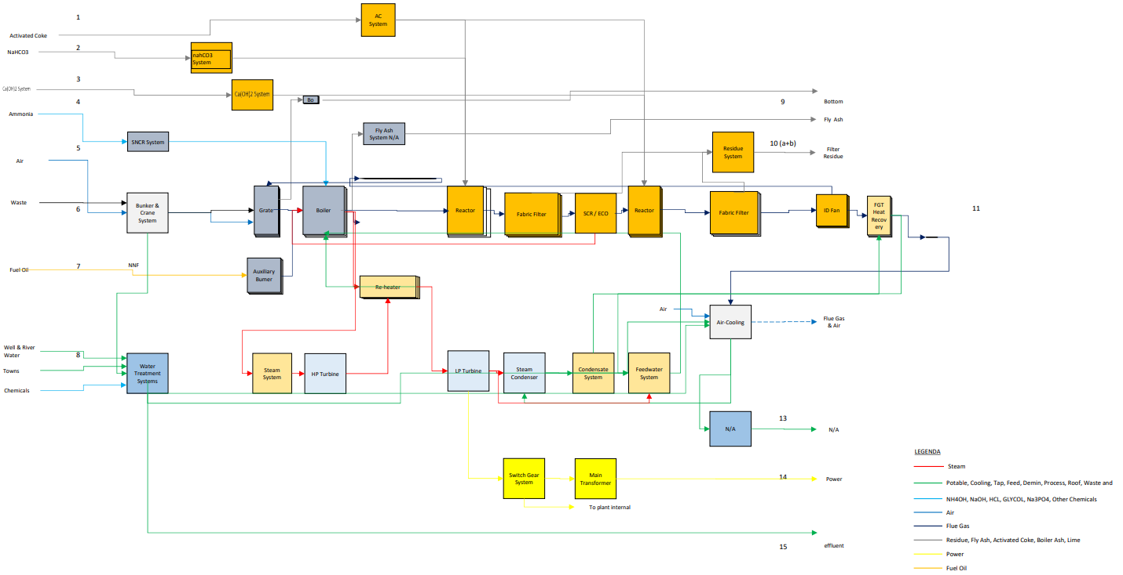

Figure Flow Diagram

For a larger version of the block flow diagram corresponding to the mass balance see Appendix D.

|  |  |  |  |  |  |  |
| --- | --- | --- | --- | --- | --- | --- |
| **Flow No** | **1** | **2** | **3** | **4** | **5** | **6** |
|  |  |  |  |  |  |  |
|  |  |  |  |  |  |  |
| **Medium** | **Activated Code** | **NaHCO3** | **CA(OH)2** | **Ammonia Water** | **Air** | **Waste** |
| **Mass/Volume** | **60 kg/h** | **750 kgh** | **76 kg/h** | **200 kg/h** | **243,300 Nm3/h** | **69,2 Mg/h** |
| **Additional Information** |  |  | **90% pure** | **25% aq.** |  | **7-9 MJ/kg** |

|  |  |  |  |  |  |  |  |  |
| --- | --- | --- | --- | --- | --- | --- | --- | --- |
| **7** | **8** | **9** | **10a** | **10b** | **11** | **13** | **14** | **15** |
|  |  |  |  |  |  |  |  |  |
|  |  |  |  |  |  |  |  |  |
| **aux fuel** | **Towns Water** | **Bottom Ash** | **FF residue** | **Filter Residue** | **Flue Gas** | **Cooling Tower Effluent** | **Power** | **effluent** |
| **TBD** | **10 m3/h** | **8180 kg/h** | **1011 kg/h** | **143 kg/h** | **371,568 Nm3/h** | **0** | **41-45 Mwel** | **3 m3/h** |
|  |  | **380 kg/h** |  |  | **60-95 Celsius** | **30 Celsius** | **11 kV/33KV** |  |

Figure 9 Mass balance sheet for the proposed WTE plant in Jenin

## Material balance statement

For the incineration plant we expect to receive 1200TPD of residual Mixed Solid Waste from JSC.

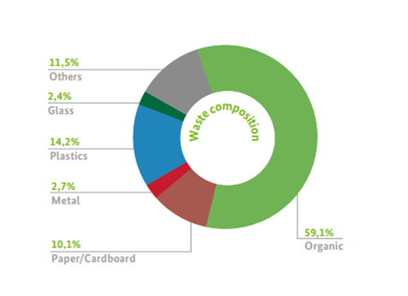Following information from recent local waste characterization studies, we may expect the inert fraction to be between 15-18% as high estimate, but most likely between 13-15%. Actual inert fraction will be mainly depending on the type of collection, stages of waste treatment prior to the waste being sent to the plant and waste acceptation standards we will agree with the JSC. For our calculations we use 15%. It is not expected that there will be much free water nor a high moisture content in the waste. The waste characterization and the total ash content of the waste needs to be assessed in the first stage of the feasibility during the *waste composition study*.

Bottom ash residue:

Moving grate incinerators produce an inert fraction of 10-18% of the total waste input as residue product, also called bottom ash. Bottom ash contains valuable ferrous and non-ferrous material which may be recovered next to granulate. Bottom-ash can have some value after proper treatment which has to be feasible under local conditions.

Describing the process for extracting the value of the bottom ash: In a first sorting step the ferrous and non-ferrous will be separated using the sophisticated technology of Blue Phoenix Group[4] who will be a possible subcontractor to the project. After that, a cleaning process for the granulates and sand will be added, and in compliance with local regulations and leaching characteristics a suitable solution will be found for the reuse of this material.

If this will be found feasible up to 95-100% of this inert fraction can be reused. Which means that potentially less than 1% of the total waste input needs to be landfilled after treatment. This can have a huge impact on the capacity outlook for the sanitary landfill.

Figure 10 below depicts the valuable bottom ash resources after treatment and the options to recover these.

|  |  |
| --- | --- |
|  | The feasibility of treatment options depends on local leaching circumstances and market conditions for granulate. If advanced treatment is not yet feasible, the bottom ash will be stabilized and securely stored in the existing landfill. Mapping out the options for bottom ash treatment will be part of the feasibility study. |
| Figure Possible Recovery Options from the Plants Bottom Ash |

FGT residue:

In the cleaning process of the flue gasses, calcium-bi-carbonate, calcium hydroxide and active coke is used to break down the toxic components in the flue gasses. In this process, hazardous salts will be formed and captured in the bag filters. This FGT residue needs to be immobilised and safely stored in secured landfills. The total production is within 1-2% of the total waste input depending on the composition of the waste.

## Supporting calculations and assumptions

For the projection below we conservatively assume the waste will have an inert fraction of 15% and an average LHV of 8 MJ/kg. We expect 1200TPD of mixed residual waste at the gate.

|  |  |  |  |  |
| --- | --- | --- | --- | --- |
| Total waste input | | Total residues | | |
| 1200 | Tons/Day | FGT residue | 1,5-2% | 7 - 9 kT/a |
|  |  | Bottom ash | 10-18% | 44 kT/a - 79 kT/a |
|  |  |  |  |  |
| 438.000 | Tons/annum | Possible Bottom ash reused | 95-100% |  |

## Life cycle cost analysis

The Consortium will own and operate the facility in a DBOOT structure for at least 25 years. As mentioned in our design philosophy, the approach chosen is therefore from the perspective of lowest Total Cost of Ownership (TCO). This means that slightly higher investments may be done upfront in equipment, staff and preventive maintenance which will more than pay back in the longer run through increased reliability, availability and lower operational cost.

AWECT originated from the Waste to Energy company AEB-Amsterdam. AEB has more than 100 years of experience in developing and operating 4 generations Waste-to-Energy plants in the city of Amsterdam. This experience provides the necessary knowledge base to prescribe the right requirements to suppliers for all equipment which needs to be installed and maintained during the operating life of the plant.

These prescriptions will be part of the tender requirements for the suppliers and EPC company/companies who will construct the plant. So, besides the international QA/QC standards as mentioned in chapter 2.5, the extensive O&M experience of WTE plants will be used in the development of the proposed plant. As will mentioned in chapter 6.3, a major overhaul interval of 2 years is chosen following the lowest TCO considerations and is based on the experience of operating the reference plant in Amsterdam. This overhaul interval will demand specific high standard standards and requirements on materials and sustainability of the equipment. The reference plant in Amsterdam is working with the same 2-year interval successfully for over 10 years. All lessons learned from the reference plant will be used in the procurement requirements for this plant. Annually, 3% of the total capex is reserved to cover operational maintenance costs, and in addition 1% of total capex is reserved annually for major overhauls. This is accounted for in the business case and based on our Amsterdam experience where these numbers were found as an optimum. During operations, we will monitor the availability of the plant and maintenance costs considering safety and environmental impact, equally balanced.

Please refer to chapter 2.6.3 for the projected cash flow statement.

# Resource Utilization Statement

## Specific Requirements according to RFB

*“A statement indicating the procurement, deployment and utilization of the resources shall be provided. The statement shall include proposed organizational structure, employee deployment, equipment procurement and utilization, contracting activities, utilization of office and other facilities.”*

Scoring Parameters

|  |  |  |  |
| --- | --- | --- | --- |
| Criteria | Parameters | Paragraph | Weight |
| Resource Utilization Statement | * Manpower deployment including CV’s of senior staff * Equipment procurement and utilization * Contracting activities * Support Infrastructure | 4.2  4.3  4.4  4.5 | 15 / 100 |

## Manpower deployment including CV’s of senior staff

Manpower during all phases of the project will be provided on a ‘best fit for the job’ basis. Northern Consortium partners are extremely well positioned to arrange the best resources for project development and the subsequent operations of the facility. Our approach is outlined in the paragraphs below. We will comply with the requirements of local labour as per article 9.1 of the Concession Agreement. The presence of Koblenz and ITEC in our consortium, both firms with good relationships with local suppliers and workforce in the cities adjacent to Jenin, signifies our commitment to meet all the requirements set by the MOLG.

### Manpower during Project Execution

In order to ensure the project will be managed successfully during all development phases (described in chapter 2.3 ), the project method[5] and organization will be expanded during the project development phases and will organically grow towards the O&M phase such that knowledge and skills developed will be firmly anchored in the organization. At the start of project execution (EPC phase), the project organization will be at full strength.

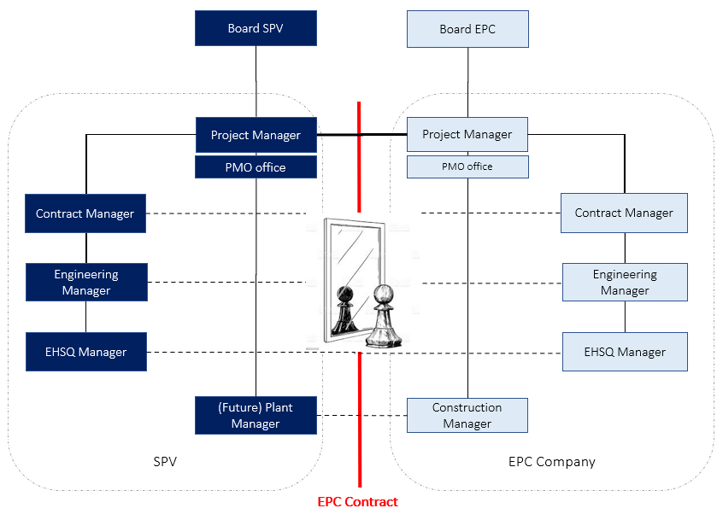

Figure 11 Mirrored Project Organization

The philosophy of the project organization itself, is based on three basic principles:

1. Separate supervision (SPV) and execution (EPC) while managing the contract, with ‘mirrored’ roles to make sure interaction and risk identification & mitigation are based on common expertise and knowledge. Profiles of senior staff roles are provided in Appendix E.
2. Create natural tension within project team by allocating aspects like time, costs, quality and scope (split), to different project roles. In this way, these interests are weighed within the project team, led by the project manager. The possible tension between various interests is therefore not obscured, but explicitly challenged.
3. Overall risk management approach is essential in the balance of interests. This will lead to decisions that achieve the best possible project result with the lowest overall project risk.

The total scope of work will be divided in separate lots, as provided below (1-9). A main EPC company to take overall responsibility of the project execution, will be selected during the Definition phase. Subsequent selection, contracting and deployment of sub-contractors and suppliers for the execution of the work itself, will be done by the EPC provider. The ‘Main EPC’ will provide a back-to-back guarantee to the SPV.

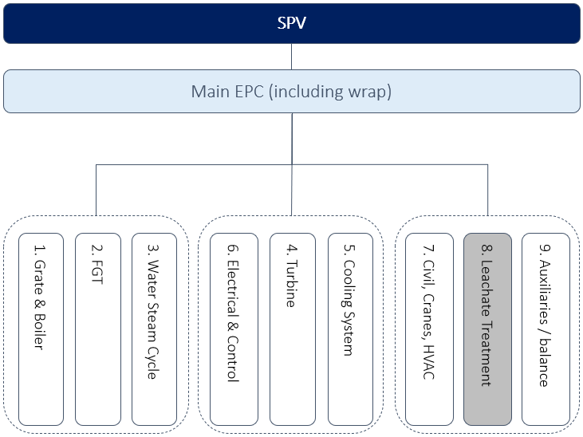

Figure 12 Division of Lots (based on ‘best for project’ principle) – Leachate Treatment is highlighted because during feasibility phase it will be decided if constructing such equipment is required for this Project.

The selected EPC provider will be strongly encouraged, through a contractual obligation, to use local resources as much as possible to comply with local labour requirements from the RFB. In the interest of proper execution of this new technology for the local EPC companies, we would like to focus this primarily on Civil works (as per Lot 7) as well as workforce available to support specialized suppliers and for support services/general services like warehousing/security/cleaning etc. The consortium performed due diligence on MACC[6] for a role as an EPC and or to take on the civil works for the project. It was found that the company is well positioned to perform parts of the civil works and even the total EPC.

Together with our consortium partner ITEC[7], we will source local contractors and operational personnel as provided in scheme 4.2.2. This scheme provides an overview of operators, maintenance, and other supporting staff necessary for a safe and efficient operations of the plant.

### Manpower during O&M / Concession period

There are no specific requirements to operate the proposed High Efficiency WTE plant at Zahrat Al Finjan compared to operating a conventional WTE plant. A total of approximately 120 operational staff is the estimated manning level required to operate the plant 24/7/365.

An estimate of the personnel and their roles versus what is necessary to operate and maintain a plant is found in the table below:

|  |  |  |  |  |  |
| --- | --- | --- | --- | --- | --- |
| Department | Field of  control | Field of control | Field of  control | Field of control | Total |
| Operations | Operators | Crane Drivers | Operations support |  |  |
|  | 30 | 10 | 8 |  | **48** |
| Logistics | Terrain Supervisor | Acceptation | Weighing bridge Operator | Residual processing |  |
|  | 1 | 8 | 4 | 10 | **23** |
| Quality | Process Technology | QA/QC | Document control | Lab |  |
|  | 2 | 2 | 2 | 2 | **8** |
| Safety | Safety operator | procedures | Environmental permits | Training |  |
|  | 2 | 1 | 1 | 1 | **5** |
| Maintenance | Cleaners | Mechanical | Electrical | Instruments |  |
|  | 10 | 5 | 5 | 2 | **22** |
| Finance & Office | Controller | Staff | Financial |  |  |
|  | 1 | 4 | 2 |  | **7** |
| IT & Process control | Office IT | Process control |  |  |  |
|  | 1 | 2 |  |  | **3** |
| Management | Operations | Finance | SHEQ | Plant Manager |  |
|  | 1 | 1 | 1 | 1 | **4** |
| Total |  |  |  |  | **120** |

Table Operational Staff estimation

### Operations staffing

The staffing and sourcing of the best suitable personnel will be organized by consortium partner ITEC. Through ITEC, professional recruitment procedures will be applied and based on their experience we will select the most fitting personnel for the given the required skills, certification and knowledge for the jobs. The local presence of Koblenz and ITEC will ensure an optimal positioning of our consortium given their knowledge and access to the local labour market. The level of education of the local population is expected to be sufficient for most of the roles mentioned above and through our local consortium partners we have good contacts to all the professional communities surrounding Jenin.

For staffing of the management team of the new plant, the management committee of the SPV will be consulted to select the operational management candidates based on CV’s and the project manager’s recommendations. During the development of the project, the SPV management committee will also select the most suitable individuals from local professional services providers to staff the O&M phase based on skills and certification (if available). The selected personnel will receive training before the plant starts operating. This will be explained in the section on training and knowledge transfer below.

The general structure for the organization to manage the plant during the concession period is depicted in the figure below.

Figure 13 Organizational Chart during Concession period

### Training and knowledge transfer

Consortium leader AWECT is currently developing a training centre in the Netherlands. Our so-called *Energy Academy* training programme is focused on training current and future personnel for operations of and in WTE and Biomass plants. The Energy Academy consists of a centre of expertise, a knowledge platform, and a learning and development approach based on job profiles and requirements from the industry combined with modern training content and methods, such as e-learning, simulators and other modern training tools at hand.

Via the Academy we will start a train-the-trainer program to ensure that new WTE plant workforces are properly prepared before operations of the new plant commence. Operational teams shall get additional insights via short training courses next to operating the plant. The training via the Academy will come in the form of a customized training plan to be set-up for the O&M Phase throughout the Concession Period for the specific plant in this Project. The training will be continuously updated to support the adequately trained and certified (if needed) personnel.

Transfer of knowledge will already take place during the Design and Construction phase and continue into the Start-up and Operations of the new WTE plant. It involves a transfer of knowledge from the international consortium partners to the Palestinian workforce that will be running the plant during the O&M phase.

## Equipment procurement and utilization

The figure below sketches an overview of the core of the HE WTE plant with its key components such as: boiler & grate, steam turbine, e-generator, economizers, and flue-gas treatment. This scheme provides a general overview and should not be interpreted as final design for the proposed plant. Slight variations are possible due to manufacturers’ specific design, or they are the result of calculations and modelling to be completed during Basic Engineering.

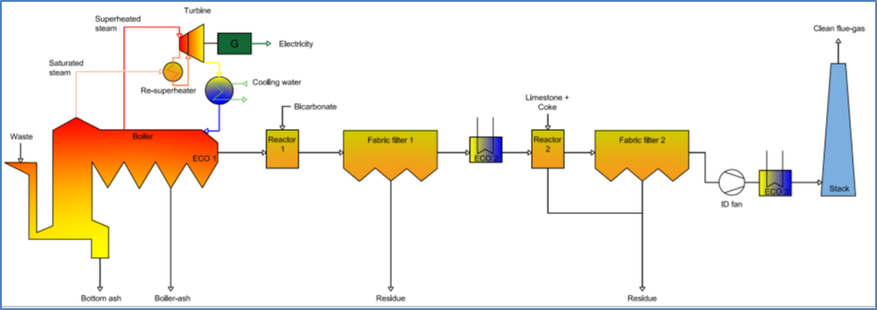

Figure 14 Plant scheme of High Efficiency WTE

Each contractor will be responsible for their lot or lots and the Main EPC will be responsible for their lots and overall integration (see Figure 12 Division of Lots in paragraph 4.2.1). As part of this responsibility, each contractor will need ensure timely and procurement of equipment following the exact specifications as set out during the Basic Engineering phase. A list of key components and major equipment, with further information is added in Appendix F.

### Local Procurement

At the start of the Project, during the feasibility phase, a study will be conducted investigating the availability of (parts of) the required equipment procurement list from Palestinian local products and suppliers as per clause 17 of the Concession Agreement.

As mentioned prior, local services and products shall be used during the Concession Period if suitable and sufficiently available. Together with our consortium partner ITEC we will source local contractors and operational personnel. For EPC and civil works, we are in advanced discussions with strong local EPC companies.

## Procurement and Contracting activities

The Procurement & Contracting plan will be created by the Contract Manager (and team) during the feasibility phase. The plan will contain an approach for the long-lead and critical items, which shall lead to official quotations in price and delivery times.

For the remaining equipment and services to the following steps shall be followed:

* Market screening local and international (minimum standards to qualify as supplier)
* Requirements per item or lot outlined (‘need to have’ and additional demands)
* Requests for quotation (RFQ) to be scheduled (detailed planning)
* Minimum of 3 bids to be achieved (unless decided otherwise by Management Committee)
* Selection and negotiations planned as per RFQ schedules

The above will follow a transparent tendering process based on Best Value Procurement philosophy, to select the most economically advantageous tenderers (MEAT) within given boundaries.

## Support Infrastructure

The required local support infrastructure and generic services will be provided or sourced by consortium partners Koblenz (who have successfully managed the adjacent Landfill site since 2009) and ITEC for local services. Where possible these services can and will be shared to allow for economies of scale and best value.

# Area Allocation Statement

## Specific Requirements according to RFB

*“The Bidder shall set out the area utilization plan for the Project Facilities.”*

Scoring Parameters

|  |  |  |  |
| --- | --- | --- | --- |
| Criteria | Parameters | Paragraph | Weight |
| Area Allocation Statement | * Overall layout plan * Mandatory Facilities placement   Support Facilities Placement  Storage Facility   * Site Conditions | 5.2  5.3  5.4 | 10 / 100 |

## Site location and overall layout

The Basic Engineering of the 1200tpd High Efficiency WTE *Zahrat Al Finjan* plant will include all required infrastructure equipment and facilities for the incineration process (in line with the key components as outlined in section 2.4), plus offices and workshops.

As can be seen in Figure 15 and Figure 16 below, the location of the plant is in the projected area Northwest of the current landfill site.

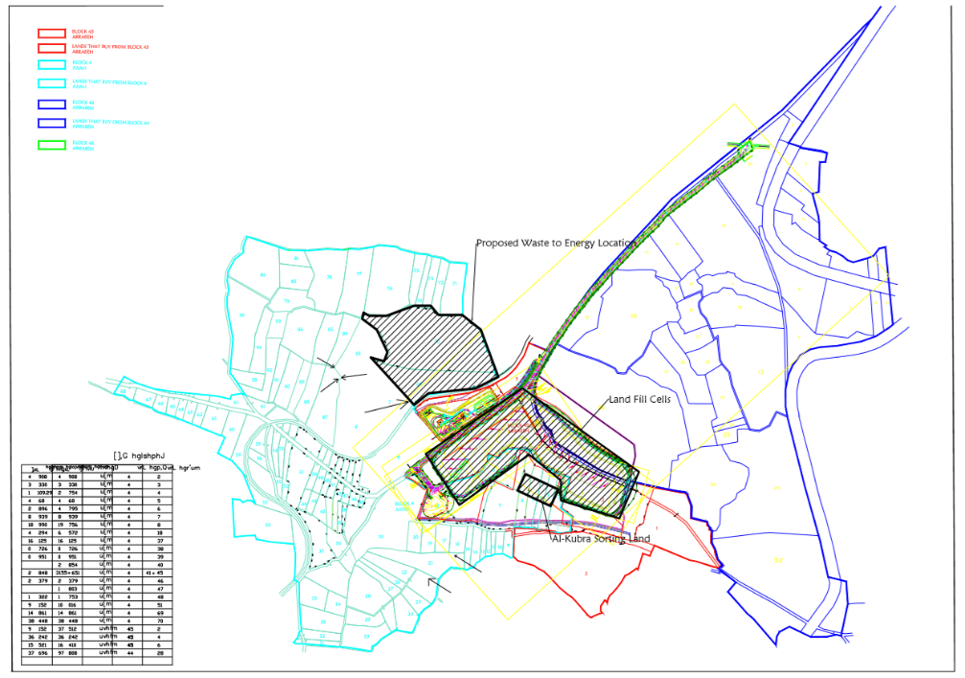

Figure 15 Overview of Zahrat Al Finjan Landfill area

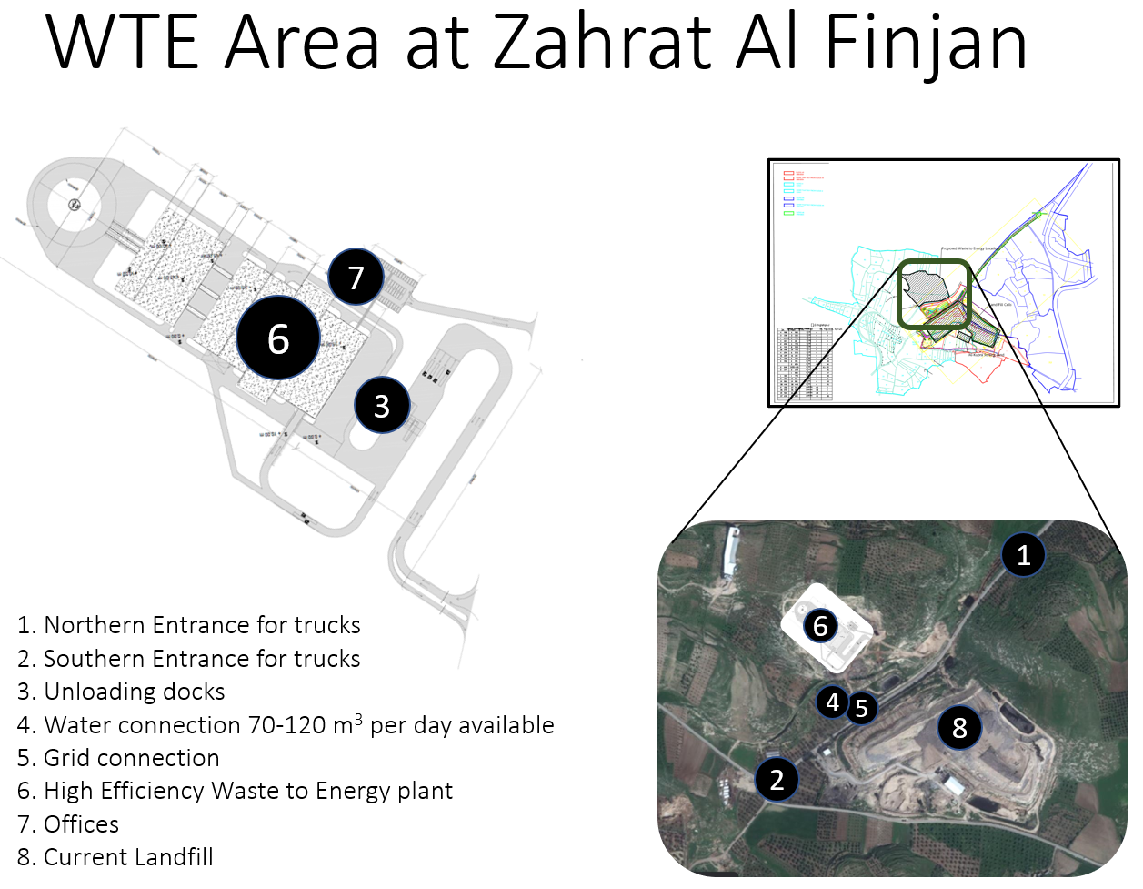

Figure 16 Preliminary Impression and layout for WTE plant at Zahrat Al Finjan

The Conceptual layout is typically planned in 3 parts:

* The middle area [6] is for the main incineration plant;
* The rear area (North of the main building) is for the other auxiliary facilities like storage, slag treatment comprehensive utilization plant and possible material recovery options, workshops and administrative building;
* The front area [7] is reserved for offices, public areas, educational centres, etc.

On the project site, we will separate garbage trucks, waste logistics [1], [2], [3] and offices [7] in smart split arrangement allowing for focus on respective aspects of health, safety and environment. The flow of the main processes is organized to avoid any possible interference, hold-up or create safety issues and it allows for easy access of the facility for operations, maintenance and safety purposes (i.e. repairs, firefighting and first-aid).

The main production plant [6] is designed in the middle of the plan; the main building is the key and core of the plant layout.

|  |  |
| --- | --- |
| **Plot size** | **Size** |
| WTE technical lay out | 1,5 ha |
| Workshops utilities public spaces and logistics | 1,5 ha |
| Slag treatment and storage (to be agreed with the adjacent landfill) | 2 - 4 ha |
| **Total** | **5 - 7 ha** |

Available space at the landfill according to the RFB is 5.5ha. This available space will be sufficient to accommodate our proposed plant. Possibly the slag treatment and some storage areas can be located at or be combined with the current landfill operation.

## Facilities Placement

Further to the arrangement of buildings and components on the site as per the above, the following principles are to be included in the plot plan to be developed during the design phases FEL-2 and FEL-3:

* For accident prevention, the refuse delivery and other plant traffic are separated.
* Major process technology components are arranged in one line, which provides a clear and simple overall plant structure.
* The separation between the boiler house and the flue gas treatment provides the additional access needed for maintenance purposes. Moreover, this allows natural lighting and aeration.
* Turbine and generator are arranged under the horizontal boiler pass, which saves space and enables short piping distances.
* In order to provide easy access to the plant in case of emergencies, all plant divisions are easily accessible from a surrounding ring road.
* The sufficiently large staging area until the weighing bridges avoids queuing of delivery trucks on the main road. The trucks will reach the elevated level of the tipping hall directly via the straight outdoor ramp to avoid difficult manoeuvring.
* Buildings are cladded and treated architecturally for a better image of the plant.

The longitudinal section shows the arrangement of the major process components, with delivery hall and bunker on the left, grate boiler and turbine in the middle, and double dry flue gas treatment to the right.

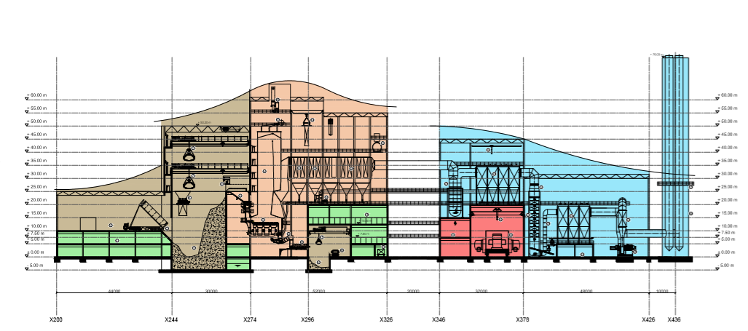

Figure 17 Longitudinal section of the proposed WTE with double dry FGT, see Appendix G.

*Traffic arrangements*

To cope with incoming traffic and avoid traffic queuing on the roads outside the facility, we intend to set up a ring road around the plant. Along this road, green belts are placed, forming a landscape Avenue.

Depending on the elevation of the main entrance to the site, we expect an elevated access will be created leading towards the tipping hall. This elevated access road will be constructed using a reinforced concrete structure. Figure 18 provides an example of this elevated road.

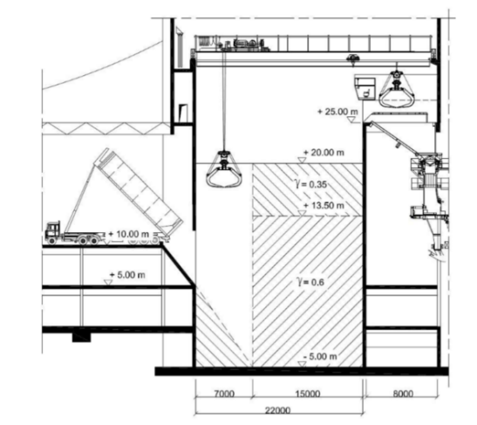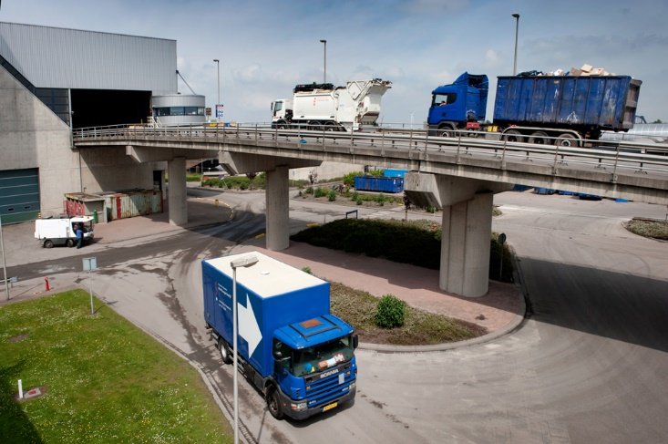

Figure Waste Delivery (left) & Tipping area cross section (right)

## Site Conditions

The site can be assumed to have no major obstacles and is free of underground obstacles, foundations, piping or cabling and war legacy. Pictures of the site below were made recently.

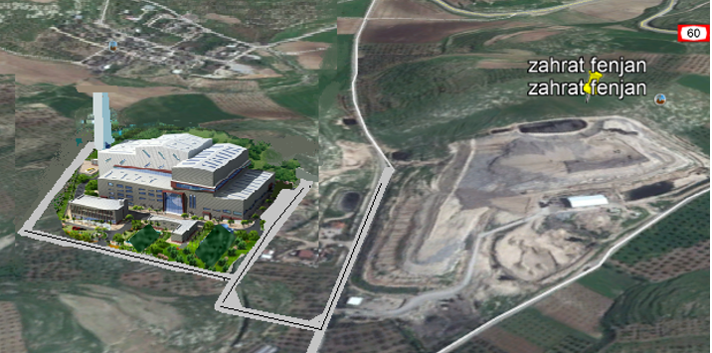

Our local knowledge of the location will be a big advantage to the project.

### Climate data

**Design Temperatures**

Annual average +22.0 °C

Maximum extreme +38 °C

Minimum extreme +0 °C

Highest monthly average +33.0 °C

Lowest monthly average +7.0 °C

**Relative Humidity**

Range (Annual Average) 53 to 63% (59%)

**Wind**

The wind speed varies between 3.3 m/s to 3.9 m/s.

### Site Access

The site access for the waste delivery trucks is using the existing highway <60> which runs to the West of the plot. The entrance and exit into and from the plant for the personnel and the visitors are planned from the Southwest corner of the plot. The Northwest corner is allocated for the separate entrance and exit for trucks. This will be further assessed during the feasibility phase (FEL-2).

The site is adjacent to the Zahrat Al Finjan Landfill operations run by Koblenz, which enables us to potentially make use of:

* Entrance control
* Perimeter control and security
* Access to existing fire-water system
* Emergency response protocols in place

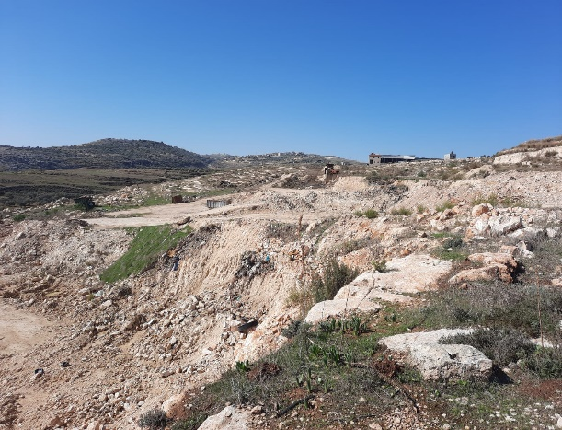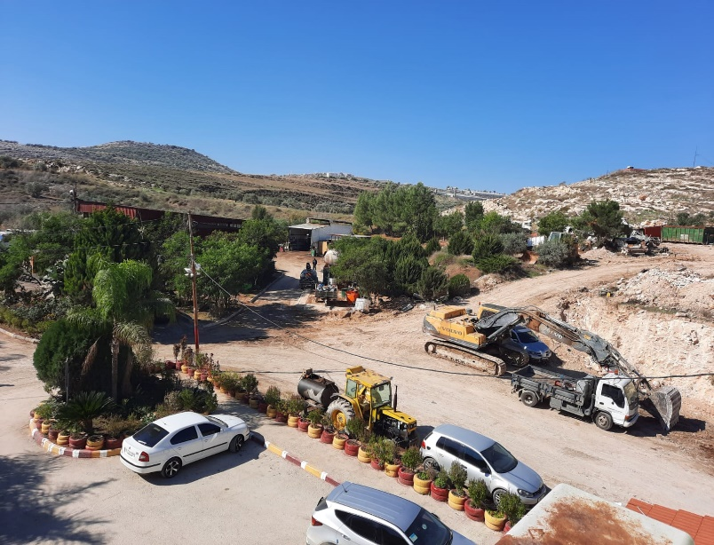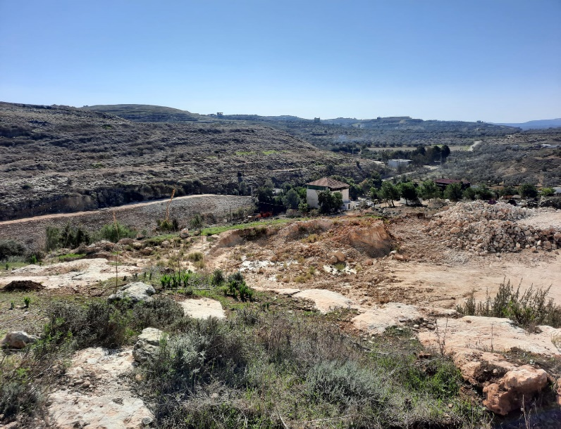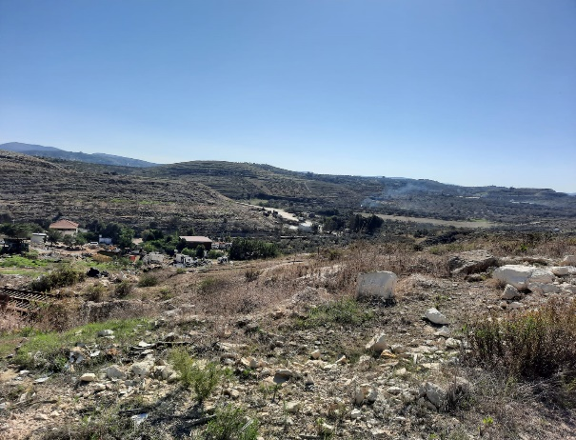

# Operations and Maintenance Scheme

## Specific Requirements according to RFB

*“The Bidder shall set out the operations and maintenance scheme during the Active Operations Period. The maintenance (regular and emergency) schedules and mechanism should also be indicated over the Concession Period.”*

Scoring Parameters

|  |  |  |  |
| --- | --- | --- | --- |
| Criteria | Parameters | Paragraph | Weight |
| Operations and Maintenance Scheme | * Overall O&M scheme * Regular maintenance plans * Emergency maintenance procedure * Risk management plan * Hand back procedure | 6.2  6.3  6.4  6.5  6.6 | 15 / 100 |

## Overall O&M scheme

The O&M scheme is part of the operational excellence scheme we propose to implement which provides a strict set of procedures following international standards as in ISO9001 and 14001.

### Start-up of Operations period

During the commissioning / start-up period (chapter 7.2), a ‘start-up team’ will be established by the EPC contractor. The start-up team is responsible for a smooth transition from Construction to Operations. The start-up team (as a part of the EPC contractor’s responsibilities) must perform its handover to a guarantee team (as a part of the O&M contractors responsibility). During design and construction the guarantee team from the O&M contractor will work together and learn how to operate the actual plant (after the training through the Energy Academy as explained in chapter 4.2.2) in cooperation with the start-up team in order to ensure a smooth handover.

The key responsibility of the O&M contractor is to deliver the performance based on the design specifications of the Northern Consortium during the design phase. The guarantee team will contribute to this goal and ensures all key parts of the plant remain compliant with agreed design parameters. The guarantee team will perform these checks and set up the (possible) claims for the suppliers of the equipment if they may not meet the desired specifications.

This process of handover from Construction to Operations phase, will be supervised by the Northern Consortium.

### Operational scheme

The ‘operational scheme’ is defined as a set of regulations (e.g. local/international (labour) laws, agreements with labour union, EHSQ-conditions) and boundaries (e.g. emission limits, grid connection boundaries, performance requirements) that the operational schedule – provided in next chapter - will comply with. The scheme will:

* Ensure the performance of the HE WTE facility, in line with the Northern Consortium proposal and the details from the design phase.
  + Performance is defined in electrical output, emission standards compliance, use of excipients, safety targets, availability at the lowest costs (TCO)
* Guided by stringent SHEQ targets and standards ISO14001
* Comply with national legislation and with international labour laws and standards according to the International Labour Organisation (ILO)[8], including the Hours of Work (Industry) Convention[9]. At the same time, it will secure workers’ rights in the workplace, such as against workplace aggression, bullying, discrimination, gender inequality, workforce diversity, workplace democracy and empowerment.
* Everything will have quality control and reporting following ISO9001/14001 standards.

The proposed operational schedule is provided in chapter 7.4.1.

All operational handlings will be captured in so called SOPs (Standard Operating procedures), which will be described in a step-by-step procedure and checklist specifying how to deal with standard situations in the plant. This will be part of an operational handbook which will be delivered at COD.

### Maintenance scheme

The ‘maintenance scheme’ covers the maintenance design principles. It defines the various types and frequencies of maintenance applicable for each component (condition based, time-based, predictive, preventive, corrective, etc). This scheme is the basis for the overall maintenance schedule.

The scheme will:

* Ensure the performance of the HE WTE facility, based on the Northern Consortium proposal and its design assumptions.
* Comply with quality standards (ISO9001/14001). As a part of this, a maintenance model is required. This is provided in the picture below, including references to chapters within this document.



Figure 19 maintenance model

Explanation of this maintenance model is provided on the following pages.

The first maintenance scheme will be set up by maintenance engineers, based on performance requirements (RAMSHE[10]) from the basic and detailed engineering plans. Depending on the criticality of the equipment and known failure data, various techniques can be applied (e.g. FMECA, RCM[11]). Suppliers must provide input for the maintenance scheme based on the specific performance characteristics and maintenance requirements of their supplied equipment. To ensure continuous improvement on performance, a strict PDCA circle will be put in place:

**PLAN** Based on the maintenance scheme, an annual maintenance schedule is set up and the planned maintenance will be prepared in detail (§7.4)

**DO** Planned and unplanned maintenance will be performed by specialized service engineers or companies, following fixed procedures (§6.3 and §6.4)

**CHECK** Based on inputs from the work performed or data - obtained from inspections or sensors – standard follow-up procedures will be defined. Also, information of failure reports and maintenance data will be analysed.

**ACT** Based on these evaluation results, improvements of the maintenance scheme will be applied. Also, these results will be important input for the ‘guarantee team’, described in paragraph 6.2.1.

**MANAGEMENT** The maintenance processes (PDCA cycle in bottom part of picture) will provide input for the management processes (top of the picture) and vice versa, including reporting.

## Regular Maintenance Plans (planned maintenance)

All measures necessary to achieve the overall plant availability of more than 90% will be detailed in the Definition Phase (basic design), EPC phase (detailed design and maintenance scheme). In these phases, the adequate and economically feasible redundancies will be defined as well.

The HE WTE design is based on the experience gained in the reference plant in Amsterdam. Dedicated equipment – like sensors to monitor critical condition parameters - is also integrated in the design to achieve the extended service intervals, high availability and prolonged plant lifetime.   
The availability of 90% (ref. Appendix A – The Reference Plant) is therefore regarded as a likely minimum.

Based on our 100 years of operational experience with Waste to Energy plants we limit the interruptions caused by planned and unplanned maintenance, raising the bar to a plant availability of more than 92%. Similar to the Reference Plant in Amsterdam we expect to use a 2 years’ maintenance interval of 17,400h. Because the plant requires a very high quality of components, maintenance (and this interval) usually forms part of the contractual agreements with the various equipment manufacturers. One shorter stop for inspection prior to the scheduled main revision is a common practice in WTE plant maintenance plans.

The maintenance scheme and schedule will be set up in close cooperation with the equipment suppliers, considering the lessons learned in Amsterdam. During the first year, after approximately 6 months of operation, an inspection stop must be scheduled. All critical items will need to be checked and measured to verify performance and compliance with the agreed design parameters. The guarantee team is responsible for the follow up with the suppliers and manufacturers.

## Emergency maintenance procedure (unplanned maintenance)

This is an example of procedures, checklists, and SOP’s for all commonly occurring events as part of the operational excellence program.



* Immediately after a failure has occurred it will be reported. Either manually by an operator or automatically detected by software and control system (depending on the type of failure).
* The notification will be assessed for urgency in the control room. If it is not an urgent failure – for example, no loss of function of the primary process or loss of redundancy of a critical process – the recovery will be planned via the regular maintenance process, described in the previous paragraph. O&M will define which type of malfunctions are defined as urgent based on the Failure & Risk Matrix as developed during the design phase.   
  Typical urgent malfunctions are (not limited to):
  + Possible or imminent loss of functionality of the key processes
  + Possible or imminent loss of redundancy of the key processes
  + Possible or imminent environmental, health or safety issues
* In the event of an urgent failure of parts the service technician is directed to fix the fault as soon as possible. To this end, he will obtain all relevant technical information from the operators in the control room.
* Once on the spot, the service technician will start with a root cause analysis (RCA) and make an estimate of the duration of the recovery. It may be that only the function of the malfunctioning part is restored and that any residual work is planned through the regular maintenance process.
* After repair, the service technician must record and report all the data so that it can be used to improve the performance of the funtional unit.

## Risk Management

An example of a risk management plan is provided in Appendix H. This risk management plan is based on the Northern Consortium O&M-reference (Reppie WTE). This plant is operated and maintained by specialized subcontractor Shandong Lineng Pvt. Ltd.

During engineering and construction, we will make use of a digital twin approach which mitigates risks between different suppliers at the interfaces. This digital twin secures as-built drawings delivered at start operations and provides a consistent database for operations.

Besides that, the consortium is developing a full scope simulator based on the reference plant in Amsterdam and modified for the project in Jenin. This simulator will check the performance and engineering assumptions in a simulated environment. The simulator will be used for training purposes as well, ensuring the O&M capabilities for the personnel of the plant.

## Hand-back procedure

The ‘hand-back procedure’ is defined as the procedure to ensure how maintenance (planned or unplanned) is transferred to return to regular operating mode, in a controlled way.

Therefore, the maintenance scheme will be worked out in specific and detailed ‘job plans’. Besides a description how to carry out the work itself, these job plans cover steps towards operation, including (but not limited to):

* Communication with control room and operators
* Tools and materials needed
* Number of people and type of skills needed
* Measures to ensure personal health & safety
* Using lock out tag out system in combination with work permits
* By use of SOP’s (Standard Operating Procedures)

Hand-back procedures will be less or more extensive, depending on size and complexity.

*Example of specific criteria for handing back a whole line (source: The Reference Plant)*

Starting up a line from ‘cold’ status includes preheating by circulating hot feed water from the central system, and ignition of the refuse. An actual start-up from the cold normally will not be necessary as at least one line will be in operation and can deliver steam and hot water for preheating purposes. The first waste fed via the hopper on the grate will be ignited by a fuse or by start-up burners. Start-up burners are used to maintain the 2 sec. 850 rule, during start up and shutdown to avoid excessively Dioxin production and to stay within the emission limits.

The whole procedure is captured in a startup check list and prescription step by step. (SOP)

# Time Schedule

## Specific Requirements according to RFB

*“The Bidder shall indicate an activity schedule over the Concession Period including the Construction Activities and O&M Activities.”*

Scoring Parameters

|  |  |  |  |
| --- | --- | --- | --- |
| Criteria | Parameters | Paragraph | Weight |
| Time Schedule | * Overall schedule * Construction activities sequencing * O&M schedule * Reporting and feedback timelines | 7.2  7.3  7.5  7.6 | 15 / 100 |

## Overall schedule

The timeline for the realization of the WTE facility starts at the issuance of the LOA. The LOA is the trigger for the developer to start the Feasibility Phase (FEL-2), followed by FEL-3 (Definition Phase), including the Basic Engineering as well as the final arrangements for Financial Close. Some detailed engineering activities can start earlier, and long lead items need early commitment, but full release and the ordering of the remaining equipment, will require Financial Close.

The EPC phase will start after Financial close, by signing the contract with the Main EPC contractor. This phase includes detailed design, procurement of suppliers, construction, commissioning and hand-over to the O&M contractor. This period will take 30 months.

After 25 years O&M phase, the concession period will end. The Northern consortium proposes two options for this situation:

Option 1: Extend the contract, with comparable period and tariff (to be negotiated)

Option 2: Transfer the WTE Plant to authorities / MoLG. Procedure to be determined

A list of assumptions for the planning is included in the remainder of this chapter.

## Construction schedule

### Approach and assumptions

The nature, numbers and duration of the tasks involved, are site specific and depend on national and local regulations to a very high degree. Requirements by the investor and other stakeholders are relevant in addition and need elaboration in the Definition Phase (FEL-3).

The following list contains the main assumptions for the planning of the construction of the HE Waste-to-Energy facility:

* Financing assumptions have been included in chapter 2.
* During Feasibility (FEL-2) and Definition (FEL-3) phase, all agreements and permits (issued by local authorities) will be approved on time.
* Execution of the work adheres to local requirements regarding quality, health, environment and safety (to be assessed).
* Smooth transport and import procedures and timelines are assumed but are to be assessed.
* Long lead items such as the boilers, grates, turbine and generator, need to be procured before Financial Close. Assumption is that upfront purchase commitments are possible.
* Availability of workforce for civil construction and component erection (incl. requested material and machines) are available. This is to be confirmed.
* The planning assumes the timely review and approval by the client of detailed design in one (1) comment round.
  + - when adjustments need to be made to approved design documents based on the clients review, consequences for the planning are not taken into account and need to be jointly agreed up front.
* All necessary data for the engineering are available at the start of the project, such as site surveys, climate conditions, etc.
* Investigation or delay for soil contamination, flora and fauna, archaeology, etc. has not been taken into account.
* No account has been taken of holidays and the likes.

There may be more issues similar to the ones listed above, which are relevant and may have to be taken into account putting together a realistic and comprehensive execution schedule for the HE WTE plant.

### Construction Activities Sequencing

For setting up a construction schedule, best practise for WTE and expert judgement were used.

Starting points for the planning:

* where possible, work is done in parallel.
* the planning is based on the basic and detailed engineering.
* local delivery of steel structure based on prefabrication.
* the site is made ready for construction before start of civil work.
* average delivery times have been taken into account for key equipment and utilities.
* piping and electrical works are part of the lead times for equipment.

The construction schedule is provided in Appendix I (the start date is fictitious).

## Operations and Maintenance Schedule

### Operations schedule

During normal continuous operation, the plant is operated by a DCS system where all control loops are shown in automatic mode. This will be monitored by the process operators during their shifts. Apart from bunker crane operation during daytime, refuse delivery or during truck loading of bottom ash, personnel are required for surveillance and in case of disturbances.

Due to the nature of the fuel, waste, operator action is required at times. All relevant process information such as pressures, flows, position of actuators, speed of drives etc. are therefore monitored in the control room by specialized personnel, supported by real time information displayed on the screens of the DCS system.

Figure 20 Control Room of the Reference Plant

Any deviation of limits triggers an alarm and operators have full access to control loop set points as well as individual actuators and drives etc. In addition to the normal process visualization as the main man/machine interface, a video camera system provides process information regarding the refuse bunker, feed hoppers, bottom ash discharge and bunker and the fire in the combustion chamber. If required, operators act remotely from the control room.

As mentioned in chapter 4, there are no specific additional requirements in operating the high efficiency HE WTE compared to a conventional WTE plant. In total there are 8 people per shift in 3 shifts on a daily basis at a full reserve capacity to cover holidays and sick relief. A 5-team schedule works best both for the employees and for the employer. The working hours are effectively 33.6 hours a week.

|  |  |  |  |  |  |  |  |
| --- | --- | --- | --- | --- | --- | --- | --- |
| Example: | | | | | | | |
| Team | mon | Tue | Wed | Thu | Fri | Sat | Sun |
| 1 | M | M | E | E | N |  |  |
| 2 |  |  | M | M | E | N | N |
| 3 |  |  |  |  | M | E | E |
| 4 | N | N |  |  |  | M | M |
| 5 | E | E | N | N |  |  |  |

*M = Morning; E = Evening; N = Night)*

A part of the work can be outsourced and will not be carried out by the O&M teams of the facility itself. This work will therefore not impact the O&M schedule. This includes work which does not relate to the core of the operational knowledge, e.g. scheduled cleaning of the boiler. This work is to be done by specialized companies who have experience in overhaul of large energy plants and other process industries.

In the start-up period we foresee additional 10 persons (start-up team) who need to adjust and align the operations during the start-up period, keeping in mind that this period is typically characterized by start-up issues which needs troubleshooting. The aforementioned 120 persons are required for a smooth operation without major start-up problems.

### Maintenance schedule

A maintenance schedule is provided in Appendix J. This maintenance schedule is based on the Northern Consortium O&M-reference (Reppie WTE). This plant is operated and maintained by specialized subcontractor Shandong Lineng Pvt Ltd.

### Training of personnel

For certain positions in the operations and maintenance team, specific skills are needed. These people need to be trained by experienced trainers who have a long history in operating waste to energy plants. As explained earlier in paragraph 4.2.2, we will use our *Energy Academy* training program based on AWECT’s knowledge of operating a HE WTE facility, to fulfil this need.   
In general, basic knowledge of thermodynamics and chemical process technology are the most desired fields of expertise. The level of education for personnel differs per contribution to the process and the specific tasks.

|  |  |
| --- | --- |
| Education level | Field of control |
| University  *6 persons* | Process technology with a background in chemistry, thermodynamics, management |
| University of applied science  *53 persons* | Operational management at the level: Process automation, electrical installation, process-operation, shift-leaders and maintenance manager, safety/environment |
| Professional education  *16 persons* | Operational personnel on the level of: Mechanics, electricians, it-specialist, operators, lab operator. Process-engineers chemical and thermal, office employees |
| No education  *42 persons* | Cleaners, residuals handling, logistics |

Operating any waste to energy plant requires a variety of skills, part of these skills need to be developed inhouse. Training of the key personnel already starts when the Basic Engineering is started and HAZOP[12] / RAMSHE studies are conducted. This provides future personnel the opportunity to get in-depth knowledge of the installation and reasoning behind certain design choices and their effect on the operation.

Next to that, additional training of WTE specific theoretical background is to be given prior to the start of operations via the *Energy Academy (see paragraph 4.2.2)*. This includes knowledge regarding specific waste to energy equipment. With this theoretical background we can start the procedural training, which is specific to the designed plant using operational windows and operational prescription of the manufacturers as a basis. Part of the training program will be a team resource management (TRM) training, to create the right transparent and inquisitive culture for sharing information to operate and maintain the plant in the most efficient way.

Besides that, the right incentives should be established for proper operation of the plant: targets around availability, efficiency, safety and emissions are the most important to achieve. These goals are to be met within the budget set for these purposes.

## Reporting and feedback timelines

Reporting of all operational events will be done automatically via a data historian, which will log all process parameters and events in the DCS system. Besides that, the operators will keep up a journal for all events which occurs during the shifts. All maintenance high priority working order will be logged and planned for upcoming maintenance moments.

During shift rotation a proper handover from this journal is provided to the succeeding team.

Every 24 hours, there is a daily operational coordination meeting involving operations, maintenance, and sales. All priorities for the day will be discussed and actions planned to ensure smooth, and safe operations of excellence which provide satisfactory result to all (intern/extern) stakeholders involved.

Weekly, monthly, quarterly reports will be produced to inform management and external supervising authorities/stakeholders. These reports will be following the principal of the PDCA cycle and international standards ISO9001/14001.

Especially the SHEQ reporting will be of interest to the supervisory authorities. Emission figures can be provided 24/7 and emission reports will be provided on a weekly base minimum. Together with the authorities a reasonable reporting scheme will be agreed. Following local regulations. Safety reporting will be done directly depending on the seriousness of the situation. This will follow the aforementioned risk matrix.

# EHS Policy and Practice

## Specific Requirements according to RFB

*“The Bidder shall indicate the environment, health and safety policy and practices, which are proposed to be adopted during the Concession Period. The aspects relating to employee and worker safety, control mechanisms of pest, odor, fire, etc. needs to be elaborated.”*

Scoring Parameters

|  |  |  |  |
| --- | --- | --- | --- |
| Criteria | Parameters | Paragraph | Weight |
| EHS Policy and Practise | * Environment management policy * Health practises * Safety related issues | 8.2  8.3  8.4 | 10 / 100 |

## EHS Management Policy

General Statement

For the Northern Consortium, Environment, Health and Safety (EHS) are key parameters during the development of the project. This is an important part of the DNA of all project partners. It will be our common goal to limit incidents to an absolute minimum and to prevent any environmental disturbance. The focus of the Northern Consortium safety policy will be at prevention of incidents by SOPs and checklists, supported by monitoring of leading and lagging indicators according to the best international standards.

During all development phases, all parties involved will be assessed to

* be certified according to international standards
* having in place an EHS training program that improves risk awareness and safety culture
* encourage responsibility for health and safety for both workers, management and selected companies or subcontractors
* having in place a monitoring system for safety.

As a consortium we will agree on the principles and targets, set in the general statement. Below is shown what EHS standards the Northern Consortium will apply, per phase.

|  |  |
| --- | --- |
| Phase | Policy |
| FEL-2 & FEL-3 | ISO 9001:2015  ISO 14001:2015 |
| EPC | ISO 9001:2015  ISO 14001:2015  ISO 45001:2018 |
| O&M | ISO 9001:2015  ISO 14001:2015  OHSAS 18001.2007 |

* **ISO 9001** This International Standards Organization (ISO) standard specifies requirements for an effective environmental management system, addressing environmental policy, organization, planning, performance, and auditing and review. Compliance with the standard is verified with a third-party review, expert panel review, or self-declaration. The standard includes a process for accreditation of procedures, giving the organization formal recognition
* **ISO 14001** is an internationally agreed standard that sets out the requirements for an environmental management system. It helps organizations improve their environmental performance through more efficient use of resources and reduction of waste, gaining a competitive advantage and the trust of stakeholders.
* **OHSAS 18001** is one of the International Standard for Occupational Health and Safety Management Systems. It provides a framework for the effective management of OH&S including all aspects of risk management and legal compliance. It addresses occupational health and safety rather than any specific product safety matters. In the near future this will be part of a new ISO 45001 version.
* **ISO 45001** is an International Standard that specifies requirements for an occupational health and safety (OH&S) management system, with guidance for its use, to enable an organization to proactively improve its OH&S performance in preventing injury and ill-health.

Appendix K provides the certificates mentioned above.

## Safety related issues

Throughout the engineering and construction phase, we will use safety parameters which will directly be reported to the representatives of the owners, as stated in the Consortium Agreement. On the site it will be part of daily reporting. The following parameters will be recorded:

* Number of fatalities throughout the engineering and construction phase (Goal Zero)
* Number of injuries (maximum of xx)
* Number of medical cases (maximum of xx)
* Number of lost time injuries (maximum of xx)
* Number of consecutive days without casualties or injuries.

This will be used to calculate two key safety standards[13]:

1. **Total Recordable Incident Rate (TRIR)**
2. **Lost Time Injury & Fatality Rate (LTIFR)**

Albeit the ultimate goals for the above metrics should always be ZERO, general industry considers a good TRIR one that is below 3.0. The exact thresholds for the indicators (“xx”) depend on the size of the workforce during the different phases and will be determined at the start of the project and communicated with all parties involved. These Key Performance Indicators will be important for the management of the project. Achieving of predefined targets will be enforced through a Bonus/Malus system. This will be also reflected in records and part of the reporting obligations to the project owner.

# Additional options

Based on the information provided by MoLG for this tender, e.g. the Feasibility Study Report from November 2018, and the local knowledge of our consortium partners, we firmly believe there are several opportunities (low-hanging fruits) for increased benefits at this specific location. These proposed add-ons should be investigated during the feasibility study phase in close cooperation with JSC and other local stakeholders.

Eco-Park and increased waste recycling

The JSC Governorate has seen a steady increase in the volume of waste disposed at the landfill. Based on projections, the waste volume is expected to grow further during the years of operations of the proposed WTE plant.

The Northern Consortium believes the WTE plant and operation of the landfill are complimentary (Northern Consortium partner Koblenz has performed operation of the landfill since 2009) and can be turned into a regional hub for waste management, a co-called Eco-Park. In an Eco-Park, various waste treatment providers such as the WTE plant for residual waste, waste segregators, plastic waste treatment, paper treatment, glass treatment, organic waste treatment through composting which can then be used as a liner for the landfill again can work in harmony to achieve maximum recovery of resources and as such become a starting point of the circular economy as referred to in the introduction.

Including these various additional waste treatment applications in the long-term concept around the waste to energy plant will help address the expected increase in volume of waste generated without the need to build additional WTE capacity or landfill waste again. Treating more waste through reuse and recycling is a preferred option in the waste treatment hierarchy compared to turning into energy via incineration. The Northern Consortium believes that existing infrastructure at the landfill combined with our expertise, knowledge and other technical solutions can be put to good use in the creation of such an Eco-Park and maximize recovery of resources.

The advanced bottom ash treatment system explained in paragraph 3.3 is part of this eco-park concept which will all work towards higher rates of waste diversion from the landfill.

Further Methane and Greenhouse Gases (GHG) reduction

The proposed plant presents the best-case regarding emissions, BUT we can do better. We propose to work together with the JSC and look at the business case to further reduce GHG emissions from adjacent sanitary landfill by installing a gas extraction system. The *Feasibility Study Report* states that this is an unavoidable solution anyway and we expect it to present synergies between the projects. Implementing this option would lead to a substantial decrease of odour nuisance, whilst maximizing the CO2 reduction and energy production at this location.

Wastewater treatment

Even though we do not envision or have plans for a leachate treatment facility in our project base case, also here we suggest to investigate adding this to the WTE facility as we are very familiar with this process and there are a lot of synergies with the WTE plant, the current landfill and providing this service for the region.

Knowledge transfer and research

Through the construction and operations of the proposed plant, a lot of knowledge transfer from the Netherlands to the Palestinian Territories will take place. This knowledge transfer and the indirect effects of this will positively enhance the local workforce and generate indirect spin-offs. If a more advanced waste management system is developed, research and further knowledge building through the cooperation of Dutch and local universities may be developed. Joint research programs and exchange programs could be developed which will further build local knowledge.

**LIST OF APPENDIXES**

|  |  |
| --- | --- |
| **Appendix** | |
| A | The Reference Plant |
| B | DNV GL Statement of Unique HE Concept |
| C | Layout of the proposed plant - SIDEVIEW |
| D | Mass Balance and Block Flow Diagram |
| E | Profiles Senior Staff Roles |
| F | Key Components and Major Equipment |
| G | Longitudinal View of the Plant |
| H | Risk Management Plan |
| I | Construction Schedule |
| J | Maintenance Schedule |
| K | Certificates |
| L | NA |
| M | Basis for Calculations |

1. https://en.wikipedia.org/wiki/Front-end_loading
2. Gate process and gate criteria available on request
3. See Appendix A. The Reference Plant for more details on the High Efficiency technology and maximization of recovery
4. https://www.bluephoenix-group.com/
5. Project methodology based on input from international project standards (PMI/PMBOK & IPMA) as well as field experience from project managers and directors.
6. http://macc.ps/ar
7. http://www.itec.ps/aboutUs.html
8. [International Labour Organisation](https://www.ilo.org/global/lang--en/index.htm)
9. [Hours of Work Convention (Industry)](https://www.ilo.org/dyn/normlex/en/f?p=NORMLEXPUB:12100:0::NO::P12100_ILO_CODE:C001)
10. RAMSHE: **R**eliability, **A**vailability, **M**aintainability, **S**afety, **H**ealth, **E**nvironment. Design criteria
11. FMECA: **F**ailure **M**ode **E**ffect & **C**riticality **A**nalysis; RCM; **R**eliability **C**entered **M**aintenance. Both methodologies to define a maintenance scheme
12. HAZOP: Hazard and Operability Analysis is a structured and systematic technique for system examination and risk management. HAZOP is often used as a technique for identifying potential hazards in a system and identifying operability problems
13. According to OHSAS 18001 (to be replaced by ISO45001 at later stage)